**Git Cheat sheet:**

1. to undo commited files of the latest commit

git reset --soft HEAD~1

2. To undo added files in git

git reset

3. To discard the changes

(use "git checkout -- <file>..." to discard changes in working directory

3. open .gitconfig file in vi editor mode

git config --global -e

4. set alias

alias lazygit="git add .; git commit -a -m '...'; git push;";

lazygit

5. commit with content of text file as commit message:

git commit --file C:/Users/E5488122/Desktop/GIT/GITCommit_Message.txt

6. Git LFS track command

git lfs track "*.jar"

7. Error: Another Process running:

Another git process seems to be running in this repository, e.g. an editor opened by 'git commit'. Please make sure all processes are terminated then try again. If it still fails, a git process may have crashed in this repository earlier: remove the file manually to continue.

rm -f ./.git/index.lock

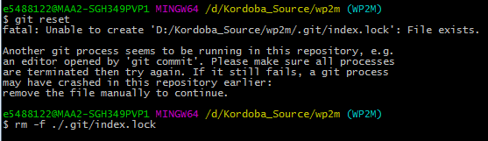

# 8. [“remote end hung up unexpectedly”?](https://stackoverflow.com/questions/36410206/why-am-i-getting-this-error-remote-end-hung-up-unexpectedly)

git config --global http.postBuffer 15728640

9. CLONE command for specific branch from bitbucket

Syntax:

Git clone <Url> --branch <Branch_Name> --single-branch

git clone https://e5488122@bitbucket.fnis.com/scm/kdbsource/kordoba_components.git --branch WP2M_develop

git clone https://kordobabitbucket.fnfis.com/scm/kdbhost/webofl_classic.git --branch K201

10. Remove a particular file from GIT Add (staging area):

git checkout HEAD -- my-file.txt

11. SSL certificate issue , set this in the global config file.

git config --global http.sslVerify false

12. Import entire repository with history to new repository

# Make a bare clone of the external repo to a local directory without a working directory

git clone --bare https://githost.org/extuser/repo.git

# now push all history and repo to new repo

cd repo.git

git push --mirror https://github.com/ghuser/repo.git # Push mirror to new GitHub repo

**13. Stashing Concepts:**

Stash a single file : **git stash save <full_Path> wp/bin/effvs1p1.pl**

Stash all files in unstaged pane : **git stash -k**